**Mini Project Report on**



**WEATHER APP using API**



**Submitted in partial fulfilment of the requirement for the award of the degree of**

**BACHELOR OF TECHNOLOGY**

**IN**

**COMPUTER SCIENCE & ENGINEERING**

**Submitted by:**

**Abhinav Shukla** **University Roll No.:2016561**

***Under the Mentorship of***

**Mr. Ramesh Singh Rawat**

**Designation**



**Department of Computer Science and Engineering**

**Graphic Era (Deemed to be University)**

**Dehradun, Uttarakhand**



**CANDIDATE’S DECLARATION**

I hereby certify that the work which is being presented in the project report entitled **“Weather App using API”** in partial fulfillment of the requirements for the award of the Degree of Bachelor of Technology in Computer Science and Engineeringof the Graphic Era (Deemed to be University), Dehradun shall be carried out by the under the mentorship of **Mr. Ramesh Singh Rawat**, Department of Computer Science and Engineering, Graphic Era (Deemed to be University), Dehradun.

Name: Abhinav Shukla University Roll no.:2016561

**Table of Contents**

|  |  |  |
| --- | --- | --- |
| **Chapter No.** | **Description** |  |
| Chapter 1 | Introduction |  |
| Chapter 2 | Literature Survey |  |
| Chapter 3 | Methodology |  |
| Chapter 4 | Result and Discussion |  |
| Chapter 5 | Conclusion and Future Work |  |
|  | References |  |

**Chapter 1**

**Introduction**

In the following sections, a brief introduction and the problem statement for the work has been included.

* 1. **Introduction**

In this project, an API based Weather application website is made. With the help of this website, we can get the information about the weather of any city and we can also forecast the weather of that city.

Weather reports and weather forecasts are made by collecting as much as possible data about the atmosphere and also by reading the atmospheric processes happening in that area.

With the help of the data about the atmospheric processes we can also determine how the weather with further evolve in the future.

But, due to the always changing nature of the atmosphere, it becomes impossible for us to completely understand the processes of atmosphere.

Due to the high need of the people, a good weather app website is needed which has a very smooth, and less complex user interface to communicate with the users and a responsive backend which can get the weather information.

**Chapter 2**

**Literature Survey**

Weather website is a very promising website built to help users the best and almost accurate data about the weather. This website is made with the help of web designing languages as its Front-end and the API.

The website is very accurate than most of the previous built weather websites as the API used are very highly reliable. Earlier traditional ways were used to know the weather of any other place but now users have much reliable option to pre plan there day. Now, one can simply visit their website portal, search for their destination and they will easily find the information about weather conditions of their destination for that particular date or future days.

The objectives provided by this project are as follows:

1. Provides the user a friendly and easy to use interface
2. Provides the user temperature of a particular place.
3. Provides the user predicted weather of somedays of a particular place
4. It will also provide the user humidity and wind speed.

**Chapter 3**

**Methodology**

The methodology followed in making this website is:

1. Create a HTML file and make the body of the website and display the required functions on the web browser
2. Create CSS file and edit the looks of the html files. With the help of CSS, the website becomes more user friendly and the function are displayed with proper designing.
3. Get API link from openweathermap.com.
4. Get API key from openweathermap.com
5. Create JavaScript file to implement client-side script to interact with the user.
6. Apply API key in JavaScript, so that we get access to the data collection on the openweathermap.
7. Open the website by executing the HTML file.
8. Our website is ready to be used, enter the name of the place and the correct output will be displayed.

The advantages of the weather website are:

1. Real time data
2. Accurate forecasts
3. Ease of use

**Chapter 4**

**Result and Discussion**

.

The result we get from our website after entering the name of the place is:

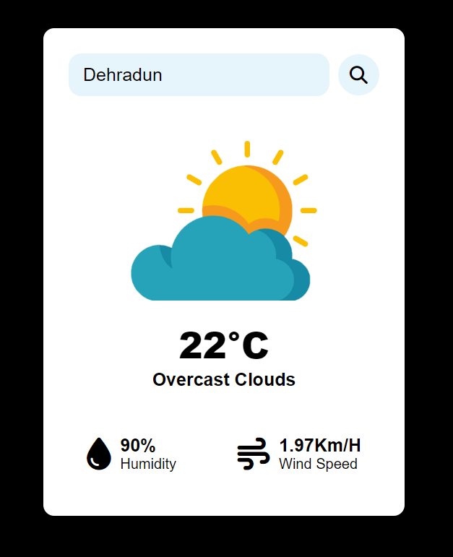 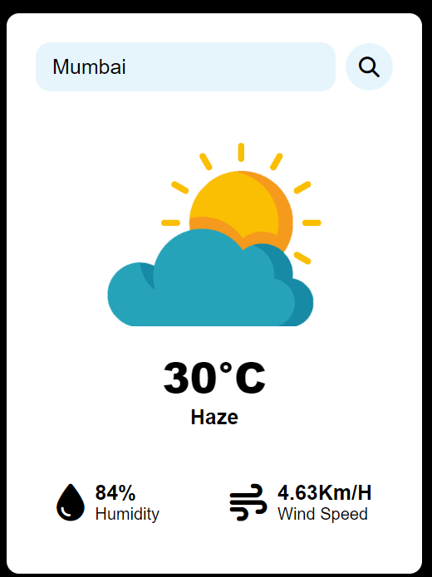

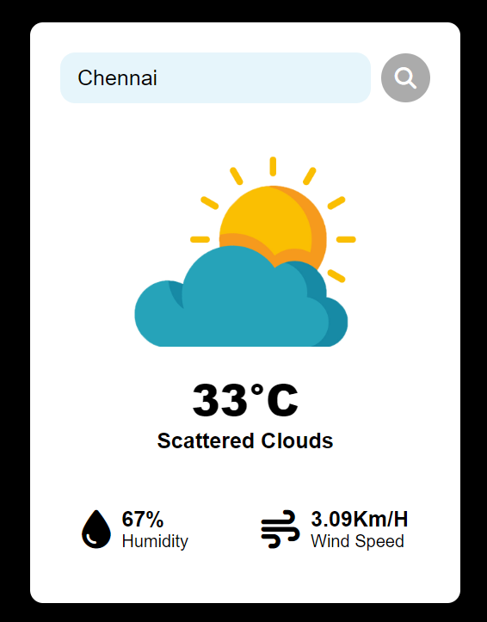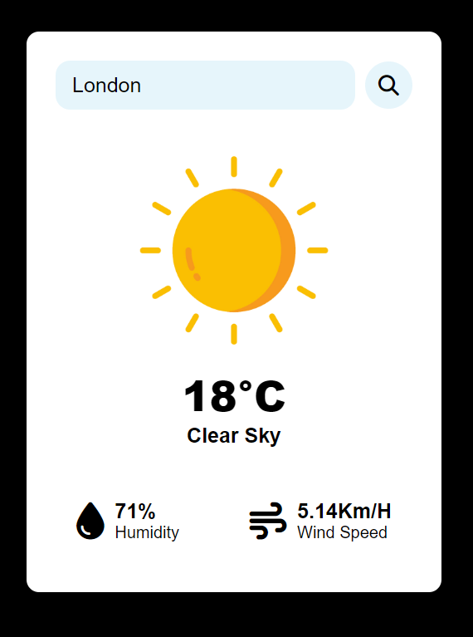

We get the information about the weather, the humidity in the place and also about the wind speed of the place.

At the end, weather is a thing which we all have to deal with. On daily basis everyone is dependent on weather and accurate details and data about how the weather is and how it will evolve helps people to plan more efficiently.

**Chapter 5**

**Conclusion and Future work**

Chapter 6

CONCLUSION

6.1CONCLUSION

Now a day’s there is a big demand of different types of applications, which is because IT has become the

main part of our New World. There is a big need of different applications. People want application for

every specific task from work to entertainment. We have developed the application “Weather

WebApp” which works easy on any given web browser.

Chapter 6

CONCLUSION

6.1CONCLUSION

Now a day’s there is a big demand of different types of applications, which is because IT has become the

main part of our New World. There is a big need of different applications. People want application for

every specific task from work to entertainment. We have developed the application “Weather

WebApp” which works easy on any given web browser.

Chapter 6

CONCLUSION

6.1CONCLUSION

Now a day’s there is a big demand of different types of applications, which is because IT has become the

main part of our New World. There is a big need of different applications. People want application for

every specific task from work to entertainment. We have developed the application “Weather

WebApp” which works easy

Chapter 6

CONCLUSION

6.1CONCLUSION

Now a day’s there is a big demand of different types of applications, which is because IT has become the

main part of our New World. There is a big need of different applications. People want application for

every specific task from work to entertainment. We have developed the application “Weather

WebApp” which works easy

In this era of technology, there is a big demand of different types of websites. People wants websites for every specific task from work to entertainment. In this project a Weather website is developed which works on any web browser

The website is tested and gives proper response quickly. This website gives the user best experience.

As for the future work, as every large or small project has some limitations. This type of API based websites also have some limitations. They are not that accurate, in future with evolving machine learning and Artificial intelligence we will be able to give much more accurate data.

**References**

[1] <https://www.vedantu.com/geography/weather-forecasting>

[2] W3Schools: This website is one of the most popular and comprehensive resources for learning HTML and CSS. It provides tutorials, examples, and references for all aspects of web development, including HTML, CSS, and JavaScript. https://www.w3schools.com/

[3] OpenWeatherMap - Provides weather data API and sample codes for various platforms. <https://openweathermap.org/>

[4] <https://en.wikipedia.org/wiki/Web_development>

[5] MDN Web Docs : This website is a project by Mozilla, and it provides comprehensive documentation and tutorials for web development technologies, including HTML and CSS.

[6] https://developer.mozilla.org/en-US/docs/Web